AWS DOCUMENT 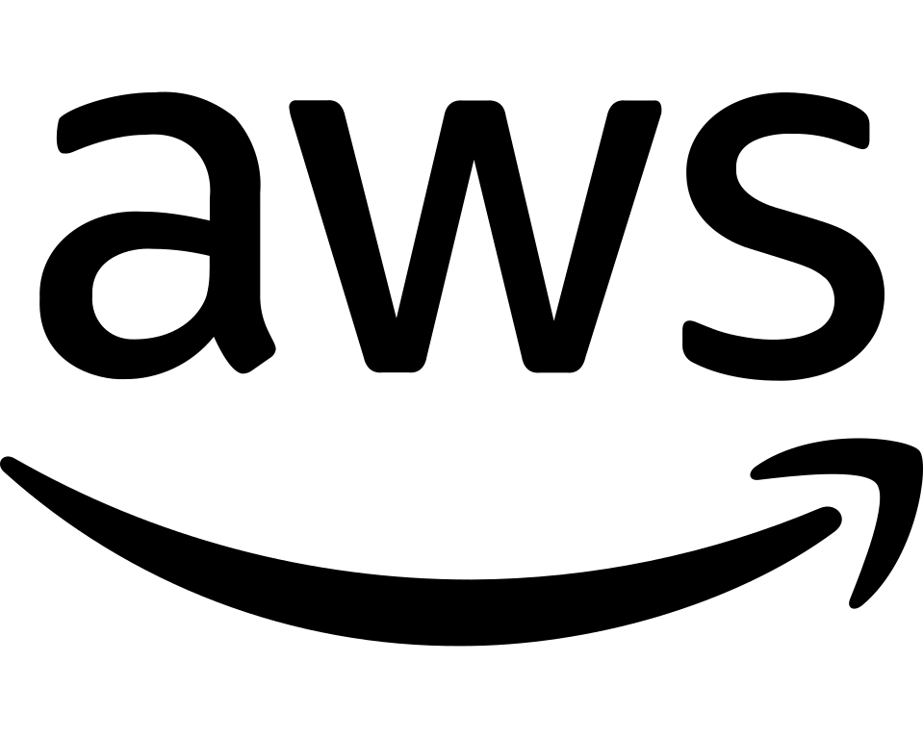
LETSUPGRADE ESSENTIAL PROGRAM
INSTRUCTOR- VINOLIN JERMIAH

AGENDA
- INTRODUCTION TO AWS
- WHAT IS CLOUD?
- CAPEX V/S OPEX
- DEPLOYMENT MODELS
- SERVICES
- FIRST STEP INTO AMAZON WEB SERVICES

DAY 2

WHAT IS CLOUD?
- It provides you a platform that can give you remote access , gives access with the help of the Internet.In the cloud you will be having better accessibility, security so that your data will be much secure.
- Cloud is a hosted service and reduces the need for physical infrastructure to lower financial investment.
- Data-center is the backbone of every company,cloud supports business looking to optimistic business processes without spending a fortune.

DEFINITION
It is a model of enabling convenient,on-demand network access to a shared pool of configurable computing. Eg- NETWORKS,SERVICES,STORAGE,APPLICATIONS AND SERVICES.

- It can be rapidly provisioned and released with minimal management effort.
- It provides High level abstraction of computation and storage models.

NOTE - Cloud is not only for storage it provides many offerings services.

ADVANTAGE OF CLOUD
- Stop guessing capacity - we are worried about my hosting application. I'm not worried about traffic.
- Increased speed and agility - if you want to deploy 20 servers you take 1 month. In the cloud you will be able to provision. These 20 servers can be launched so soon.
- Focus on business differentiation - Instead of spending time in analyzing the traffic you can focus on how to improvise your projects.
- Variable vs capital expense
- Go global in minutes - able to span across the globe to the data center.

ECONOMIES OF SCALE-[understanding business expenses]
If you want to produce on a large scale you should be able to get a lot of benefits, by gaining profits. Any organization wants to launch they go to cloud bcoz it offers them some kind of profit.

How do they achieve it?

If my organizations wants to gift all their employees they will buy it in numbers, but if a employes want to gift they can purchase max one or two gifts piece the same work of amount will initial work is same but only thing is difference between large-scale and small-scale business, hence large-scale has large investments.

- Cost adv companies experience when production becomes efficient.
- A business size and achieving an economy of scale.
- Internal economies are caused by factors within a single company.
- External factors affect the entire industry.

CAPEX VS OPEX

CAPEX
(Capital expenses)
OPEX
(operational exp)
Long lead times for new equipment,significant staff integration effort required.

Equipment failures.

overprovisioning/wasted capacity.

Hvac,electricity,facility,insurances.

Low value maintenance staff required.

Config error can be costly and difficult to remediate.

On demand services are designed for plug and play(PAAS).

Automated instance health maintenance.
Buy only what you need.

None of these things are required.
Cloud provider maintains underlying hardware.
Software defined services are easily re-configured.

DEPLOYMENT MODELS

4 types of models

Public cloud- a/c which we have is public and that can be accessed by anyone across the globe.

Private cloud- this can accessed only by me or to be a member of this access.

Community cloud -2 or more organizations want to work together and they will be having some shared data, there will be 4 groups they will collaborate and share the data.

Hybrid cloud - any business they want to optimize the business, to reduce the amount where we spend resources. You can use the combination of public/private.

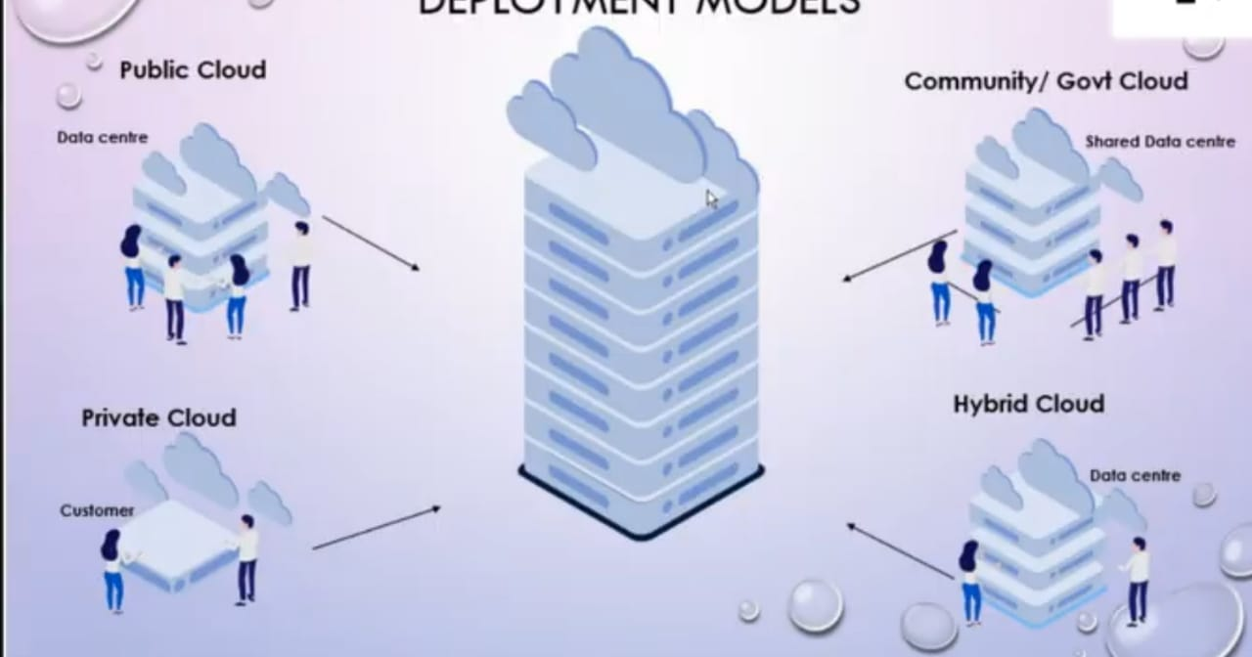 Fig 1 represents Deployment model

Characteristics of Public cloud
- A public cloud is a publicly accessible cloud environment owned by a third-party cloud provider.
- The IT resources on public clouds are provisioned as per service models.
- The cloud provider creates and manages public cloud and its IT resources.

Characteristics of Private cloud
- A private cloud is owned by a single organization.

- An organizational department that assumes responsibility for providing the cloyd plays the cloud provider ride.

NOTE
If it is a public cloud the provider is providing all the resources you are the user so you have complete control in your network so whereas in public someone control your network.

Characteristics of Hybrid cloud

- A hybrid cloud where two or more different clouds can be combined.
- Deploy cloud services processing sensitive data to private cloud.

Characteristics of Community cloud

- Not everyone will be the access of resources only the decided part of resources will be granted permission to access for the groups.

SERVICE MODELS

3 different types of service models:

- INFRASTRUCTURE (as a service)
- PLATFORM (as a service)
- SOFTWARE (as a service)

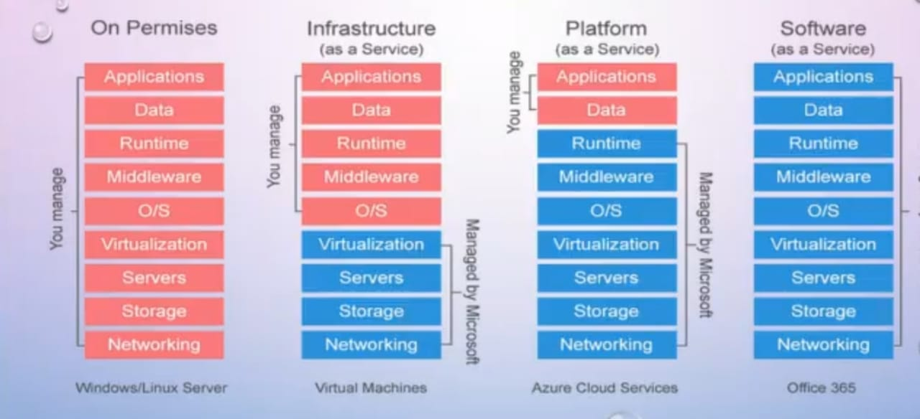
Fig 2 represents Service Model

INFRASTRUCTURE AS A SERVICE

- As a consumer you will be responsible for most of the layers. In the above figure2 you can see that virtualization,servers,storage,networking everything will be given by the managers and you will be responsible for the setting up the runtime,data,middleware,o/s you will be playing a major role in this.

IAAS CHARACTERISTICS

- Resources are available as a service.
- The cost varies depending on consumption.
- Services are highly scalable.
- Provides complete control of the infrastructure to organizations.
- Dynamic and flexible.

WHEN TO USE IAAS?

- For a startup or a small company-less capital cost for hardware and software.
- For large organizations to have complete control over their applications and infrastructures.
- For rapidly growing companies you don't have to commit to a specific hardware or software as your needs change and evolve.
- Ambiguity in demands for a new application.

IAAS ADVANTAGES

- most flexible and scalable cloud computing model.
- Automated deployment of storage,networking,servers and processing power.
- Gives clients complete control of their infrastructure.
- hardware/resources can be purchased as needed.

PLATFORM AS A SERVICE

Here you are provided with the platform and then you can deploy your application. The capability provided to the consumer is to deploy onto the cloud infrastructure acquired applications created using programming languages. Libraries ,services and tools supported by the provider.
Also the consumer does not manage or control over underlying cloud infrastructure including network,servers, O.S storage.

NOTE-
In infrastructure the resource will be provided you would have to set up your own environment and you should deploy the application. In the platform service environment will be provided you should deploy it.

PASS CHARACTERISTICS

- Numerous users can access the same development application.
- Web services and databases are integrated.

WHEN TO USE PAAS?

- Flexible to accommodate multiple developers working on the same development project.
- To create your own customized applications.
- Reduce costs for rapidly developing in the app.

PASS ADVANTAGES

- Makes the development and deployment of apps simple and cost-effective.
- Scalable.
- Highly available.
- Reduces the amount of coding.
- Allows easy migration to the hybrid model.

Examples of PAAS -

- Aws elastic beanstalk
- Windows azure.
- Google app engine
- Apache stratos
- Openshift

SOFTWARE AS A SERVICE

You will get the end-application from the providers. To train your work force or navigate your application. Final end product from your provider.

The capability provided by the consumer is to use the providers applications running on the cloud infrastructures.

SAAS CHARACTERISTICS
- Managed from a central location.
- Hosted on a remote server.
- Accessible over the internet.
- Users not responsible for hardware or software updates.

WHEN TO USE SAAS?

- If you are a startup that needs to launch ecommerce quickly and don't have time for server issues or software.
- For short-term projects that require collaborations.
- For applications that need both web and mobile access.

EXAMPLES OF SAAS
- Google apps
- Dropbox
- Salesforce
- Goto meeting.

FIRST STEPS INTO AMAZON WEB SERVICES

GLOBAL INFRASTRUCTURES OF AWS - DATA CENTERS

- AWS global infrastructure has 24 launched regions
- 3 announced regions and 77 availability zones.
- Region - it is a geographical area and each region contains 2 or more AZ.
- Availability zone - an AZ is a simple data center.
- In India- Asia Pacific(MUMBAI) region has 2 Availability zones.

These data centers manage all the resources, the accounts which you created will have a lot of resources that will be managed by some data centers across the globe.every provider will be having their own data center.

DOMAINS IN AWS

